AIoT Developer InnoWorks 2026 - Hosted by Phenikaa University - Initiated by Advantech
PROPOSAL FORM FOR ADVANTECH AIoT InnoWorks 2026
Theme: Edge Computing & AI-Powered WISE Solutions | Field: Energy & Environment

PART 1 - OVERALL INFORMATION
University Name | Thai Nguyen University of Information and Communication Technology (ICTU)
Department / Institute | Information Technology
Professor Name (Applicant / Host) | Dao Thi Hang - M.Sc., Lecturer
Email | dthang@ictu.edu.vn
Phone | 0975 375 312

OVERALL INFORMATION & RESOURCE REQUIREMENT
Duration of AIoT InnoWorks | Skills development (WISE-IoT self-learning & certification): 2026/08/01 to 2026/09/10  Application development: 2026/08/01 to 2026/11/20  Final Demo Day: 2026/11/27
Number of students participating | 01 team - 05 members
WISE-IoT training slots needed | 05 accounts
WISE-IoT space open duration | 2026/08/01 ~ 2026/12/30

PART 2 - PROJECT INFORMATION
Team Name | Hu Tieu
No. of Team Members | 05
Project Topic | EV Battery Thermal Monitoring System with Embedded AI: Remaining Useful Life Prediction and Early Anomaly Detection
Adviser | Dao Thi Hang (M.Sc., Lecturer)
Member background (department) | All members are from Information Technology / Computer Engineering, ICTU (cross-disciplinary, with prior hands-on experience in IoT/AI and cloud connectivity).
Team Members
No. | Full name | Student ID | Role
1 | Pham Van Huynh | DTC245200357 | Leader
2 | Nguyen Hoang Anh Tuan | DTC255010084 | Member
3 | Hoang Van Huy | DTC255220030 | Member
4 | Dam Duc Don | DTC245010002 | Member
5 | Pham Minh Tu | DTC245010007 | Member
Project Introduction
Target audience
The proposed solution targets owners and manufacturers of electric two-wheelers (e-motorcycles and e-bikes), as well as fleet operators and EV charging service providers in Vietnam. With more than 3.5 million electric motorcycles currently in operation and an annual market growth rate of approximately 20%, Vietnam represents a promising environment for deploying intelligent battery-health monitoring technologies.
Problem to be resolved
Thermal runaway and abnormal temperature rise in lithium-ion batteries remain major causes of battery degradation and fire incidents. Conventional Battery Management Systems (BMSs) primarily rely on threshold-based monitoring, generating alarms only after safety limits have been exceeded. Consequently, they lack the capability to predict impending failures or identify subtle abnormal operating patterns at an early stage.
Proposed solution
This project proposes a low-cost, plug-and-play intelligent battery monitoring system that integrates a two-tier Embedded AI architecture. The proposed architecture combines ultra-low-power TinyML inference on microcontrollers with edge intelligence deployed on a Raspberry Pi, while leveraging the Advantech WISE-IoT platform for cloud-based monitoring, data management, predictive analytics, and maintenance reporting.
Functional / System Architecture
The system follows a three-layer edge-to-cloud architecture in which intelligence is pushed to the device, while the cloud layer is built on Advantech WISE-IoT for connectivity, storage, visualization and alerting:
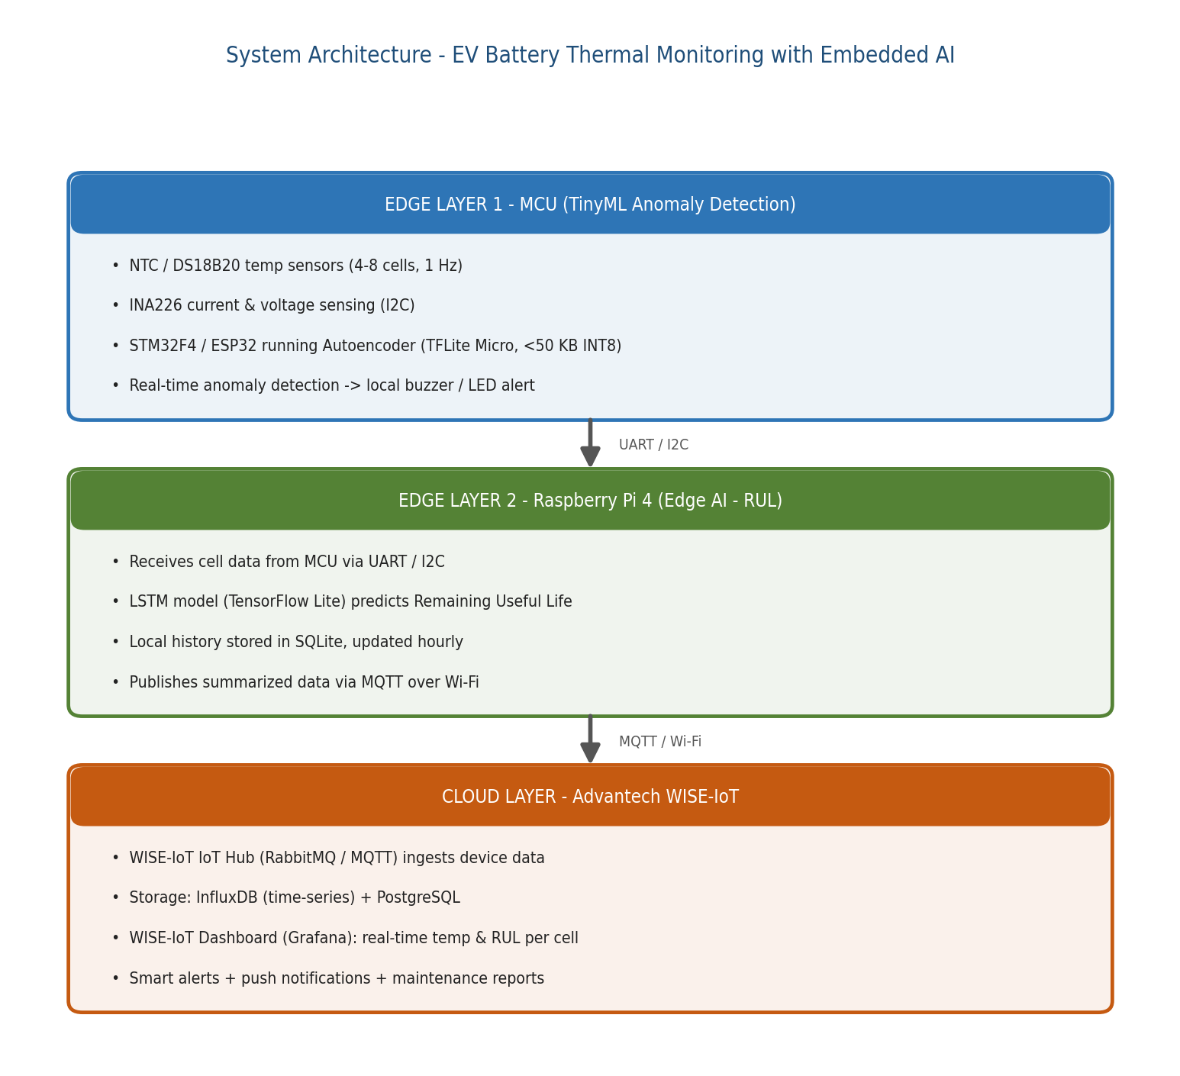
Figure 1. Three-layer Edge AI architecture, with Advantech WISE-IoT as the cloud layer.
How Edge AI / Edge Computing Is Utilized
Edge Layer 1 (TinyML on MCU): An INT8-quantized Autoencoder (<50 KB) runs directly on an STM32F4 / ESP32 using TensorFlow Lite Micro. It learns the normal operating signature of each battery cell and flags deviations in real time, giving an early warning 10-30 minutes before an overheating risk. Because inference is on-device, it keeps working even with no Internet connection.
Edge Layer 2 (Edge AI on Raspberry Pi 4): An LSTM model runs on the Pi 4's ARM Cortex-A72 CPU to predict the battery's Remaining Useful Life (RUL). The task is latency-tolerant (hourly inference), so no GPU is required - reducing cost and power versus edge-GPU boards such as Jetson Nano. Only summarized results are forwarded upstream, which lowers bandwidth and protects against connectivity loss.
Cloud Layer (Advantech WISE-IoT): Summarized data is published via MQTT to the WISE-IoT IoT Hub (RabbitMQ), stored in InfluxDB (time-series) and PostgreSQL, and visualized on the WISE-IoT Dashboard (Grafana) showing real-time per-cell temperature and RUL trends, with smart alerts, push notifications and periodic maintenance reports.
Models are trained offline on the public NASA / CALCE battery dataset (>1,000 labeled charge cycles) and converted to TensorFlow Lite / ONNX for embedded deployment.
Expected Benefits & Practical Impact
- Improved safety: proactive (predictive) detection that prevents fires before they happen, instead of reactive threshold alarms.
- Quantified battery health via the RUL index, enabling planned maintenance and battery replacement.
- Lower cost & longer battery life: prototype hardware under 3.5M VND; target unit ~300,000-500,000 VND plus ~50,000 VND/month SaaS - far below the cost of replacing a battery pack (3-10M VND).
- Scalable business model: hardware module + cloud subscription, expandable from personal EVs to shared fleets, e-buses and battery-storage warehouses.
- Strong alignment with InnoWorks: the WISE-IoT cloud layer is central to the design, satisfying the competition's emphasis on WISE-IoT usage.

